**EXPERIMENT 1**

**AIM:** To understand the DevOps principle practices and DevOps engineer role and responsibilities.

**DevOps Principles-**

DevOps is a software development methodology that emphasizes collaboration, communication, and integration between software developers and IT operations professionals. DevOps engineers are responsible for implementing and managing the tools, processes, and infrastructure needed to support this methodology. Here are some key principles that DevOps engineers follow:

1. Automation: DevOps engineers automate as many tasks as possible, including testing, deployment, and monitoring. This helps to reduce errors and increase efficiency.

2. Continuous Integration and Continuous Deployment (CI/CD): DevOps engineers use CI/CD pipelines to automate the process of building, testing, and deploying software. This helps to ensure that changes are quickly and safely integrated into the production environment.

3. Infrastructure as Code (IaC): DevOps engineers use IaC tools like Terraform and Ansible to manage infrastructure as code. This allows them to automate the provisioning and configuration of infrastructure, making it easier to manage and scale.

4. Collaboration: DevOps engineers work closely with developers, operations teams, and other stakeholders to ensure that everyone is aligned and working towards the same goals.

5. Monitoring and Logging: DevOps engineers use monitoring and logging tools to track the performance of applications and infrastructure. This helps to identify issues and improve the overall reliability and performance of the system.

6. Security: DevOps engineers prioritize security throughout the software development lifecycle. They use tools like vulnerability scanners and penetration testing to identify and address security issues.

By following these principles, DevOps engineers can help organizations to deliver software faster, with higher quality, and with greater reliability.

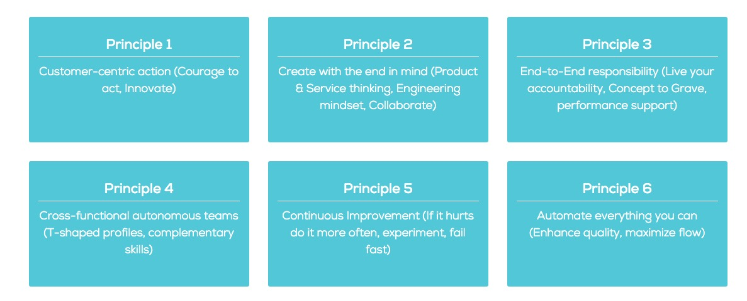

**DevOps Practices-**

DevOps is a set of principles and practices aimed at building an efficient team that improves communication and collaboration. It is not just a set of tools, but a cultural and technical shift that requires significant investment in time, effort, and resources. DevOps practices are focused on using the latest generation tools to automate the configuration process for system resources and application components. Continuous integration, delivery, and deployment (CICD) is widely used in DevOps communities, as it allows for teams of all sizes to deploy rapidly-changing hardware and software resources quickly and confidently. A Multivocal Literature Review conducted in 2023 identified 37 organized DevOps capabilities and their definitions, and mapped the concepts of practices and capabilities in an ordered taxonomy.

1. Continuous Integration/Continuous Deployment (CI/CD): This practice involves automating the process of integrating code changes and then deploying them to production or testing environments.

2. Infrastructure as Code (IaC): IaC involves managing and provisioning computing infrastructure through machine-readable definition files, rather than physical hardware configuration or interactive configuration tools.

3. Collaboration and Information Sharing: DevOps emphasizes increased collaboration and information sharing between development and operations teams to improve efficiency and reduce errors.

4. Automation: Automation of repetitive tasks such as testing, building, and deployment is a key practice in DevOps, aiming to increase efficiency and reduce human error.

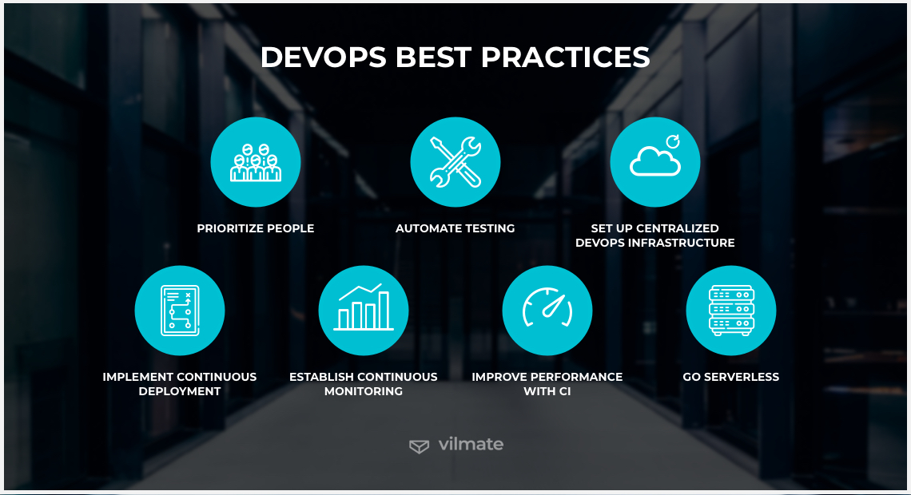

**Roles of a DevOps Engineer-**

DevOps engineers play a crucial role in software development and IT operations. Their responsibilities typically include automating and streamlining the software development and infrastructure management processes, implementing and managing continuous integration and deployment (CI/CD) pipelines, monitoring system performance, and collaborating with cross-functional teams to ensure smooth and reliable software delivery. They are also involved in implementing security best practices and managing cloud infrastructure. Overall, DevOps engineers are responsible for bridging the gap between development and operations, with a focus on improving collaboration, efficiency, and quality throughout the software development lifecycle.

DevOps engineers play a crucial role in software development and IT operations. Their responsibilities typically include:

1. Automating and streamlining the software development and infrastructure management processes.

2. Implementing and managing continuous integration and deployment (CI/CD) pipelines.

3. Monitoring system performance.

4. Collaborating with cross-functional teams to ensure smooth and reliable software delivery.

5. Implementing security best practices.

6. Managing cloud infrastructure.

Overall, DevOps engineers are responsible for bridging the gap between development and operations, with a focus on improving collaboration, efficiency, and quality throughout the software development lifecycle. This is supported by the identification of DevOps engineers as a mix of developers and operations engineers, focusing on both code commits and task assignment and acceptance testing. Additionally, they play a vital role in overcoming obstacles to collaboration between developers and IT security professionals.

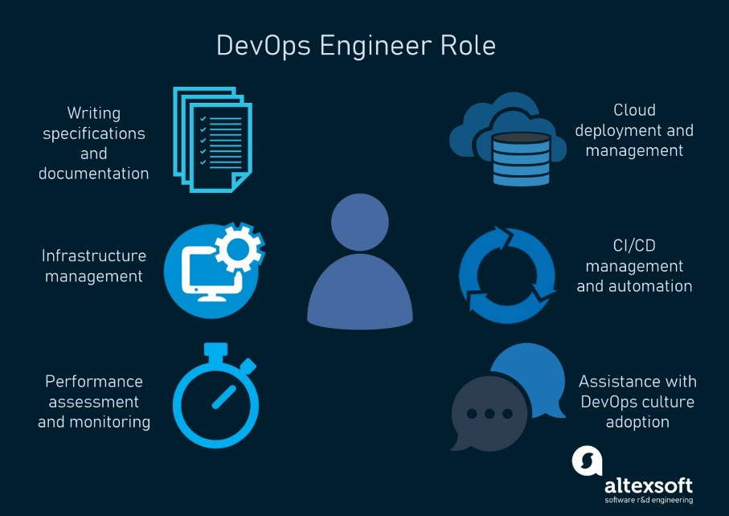

**Responsibilities of DevOps engineer-**

1. Continuous Integration and Deployment: DevOps engineers are often responsible for implementing and managing continuous integration and continuous deployment (CI/CD) pipelines. This involves automating the building, testing, and deployment of software, enabling faster and more reliable release cycles.

2. Infrastructure as Code (IaC): DevOps engineers work with IaC tools such as Terraform, Ansible, or CloudFormation to automate the provisioning and management of infrastructure. This approach ensures that infrastructure is version-controlled, reproducible, and consistent, reducing the risk of configuration drift and human error.

3. Monitoring and Incident Response: DevOps engineers set up and maintain monitoring and alerting systems to track the performance and health of applications and infrastructure. They also play a key role in incident response, identifying and resolving issues to minimize downtime and maintain service availability.

4. Security and Compliance: Ensuring the security and compliance of the software delivery process is another important responsibility. DevOps engineers collaborate with security teams to integrate security best practices into the development lifecycle and implement measures such as code scanning, vulnerability assessments, and access control.

5. Collaboration and Communication: Effective communication and collaboration with cross-functional teams are essential for DevOps engineers. They often facilitate discussions between development, operations, and other stakeholders, working to align goals, share knowledge, and drive a culture of continuous improvement.

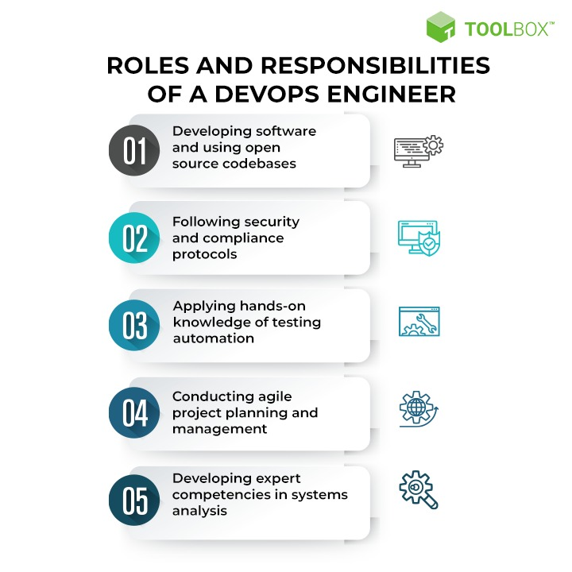

**CONCLUSION**: Hence, we have studied about DevOps principles and practices and DevOps engineer roles and responsibilities.